Catharina Mellon Foundation Bondali, Gambia
2018 - 2020
Mafugi Drammeh, Gambia, Daniela Filthaut , Germany
bondalischool@gmail.com
2018 - 2020

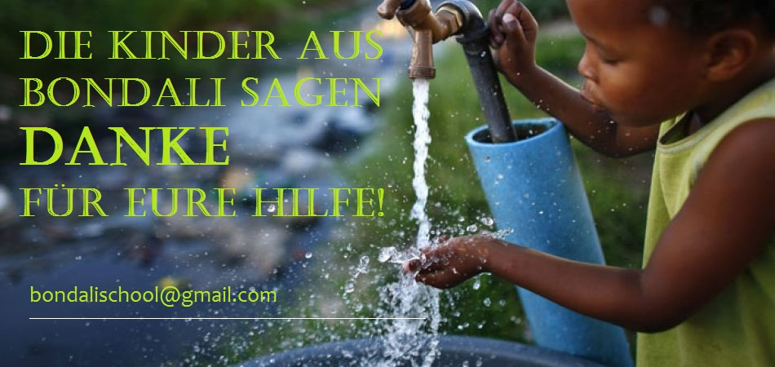
Founded by Ralph Mellon and Mafugi Drammeh in 2014, named by his mother Catharina Mellon and land given by the village of Bondali, the story of the school go ahead again in 2018 ...
On a vacation trip in early 2018, I saw the living and educational conditions in Gambia, West Africa. Spontaneously I decided to support a small school deep in the forgotten backland, 125 km far from the coast. About 200 children are now being taught in primary and kindergarten.
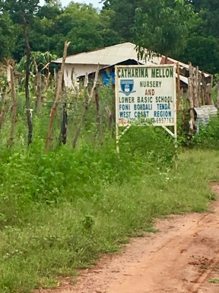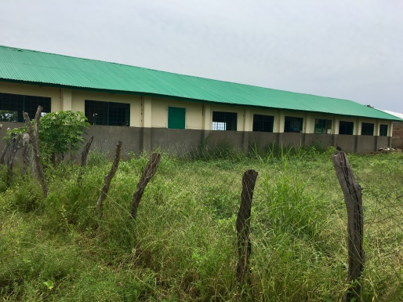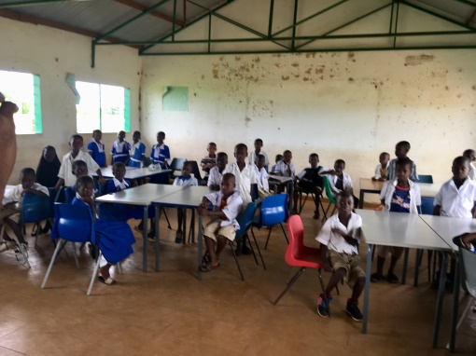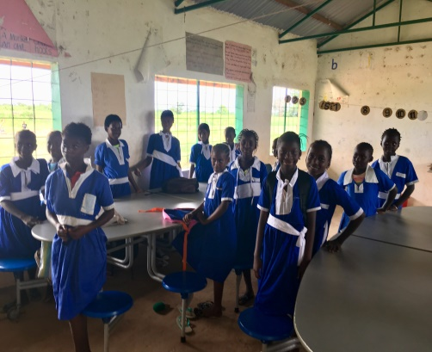
We the help of family and friends we finished building the kitchen barrack, pantry and dining room at the beginning of 2019, so that there is now one meal a day at school for the children.
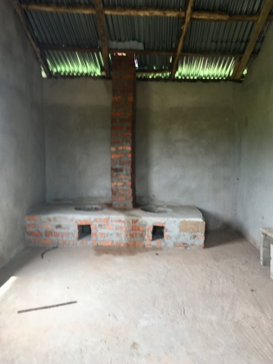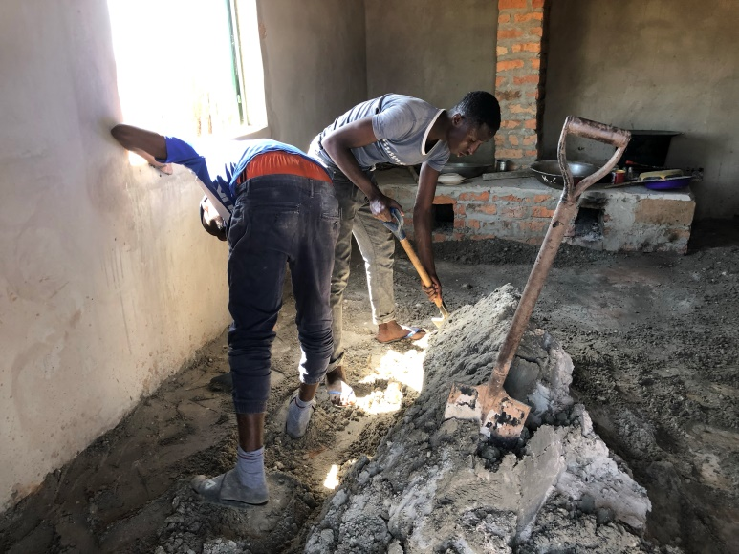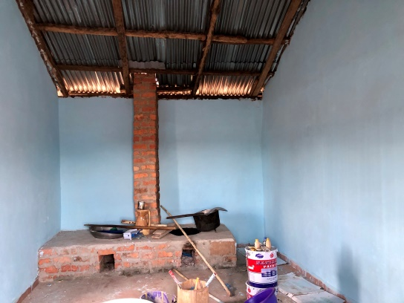
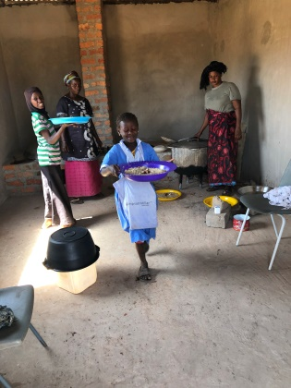 The first plate with rice! The finished kitchen!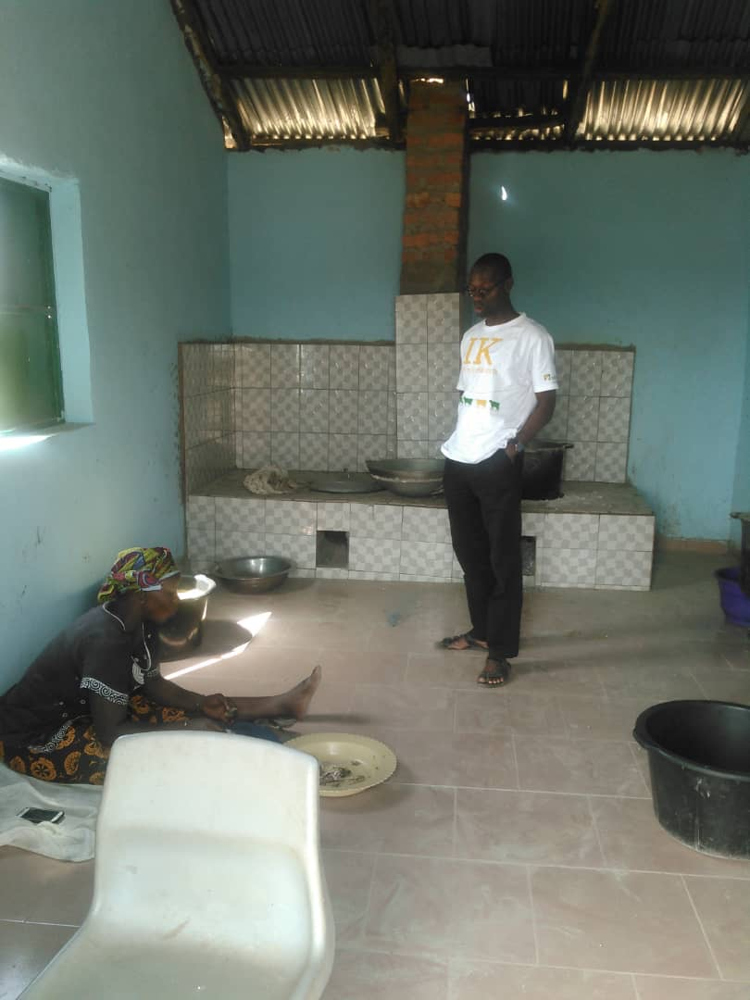
In summer 2019 two times we repaired the groundwater solar pump - the only vital access to clean water in the area! A dangerous situation for the children and the village of Bondali!
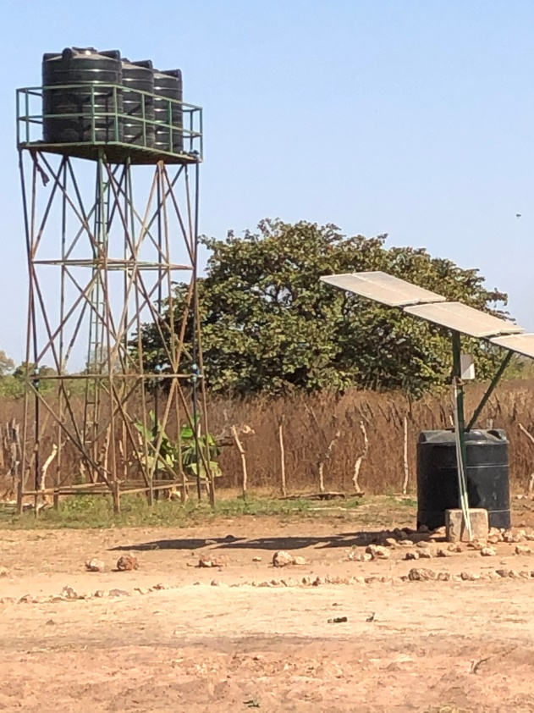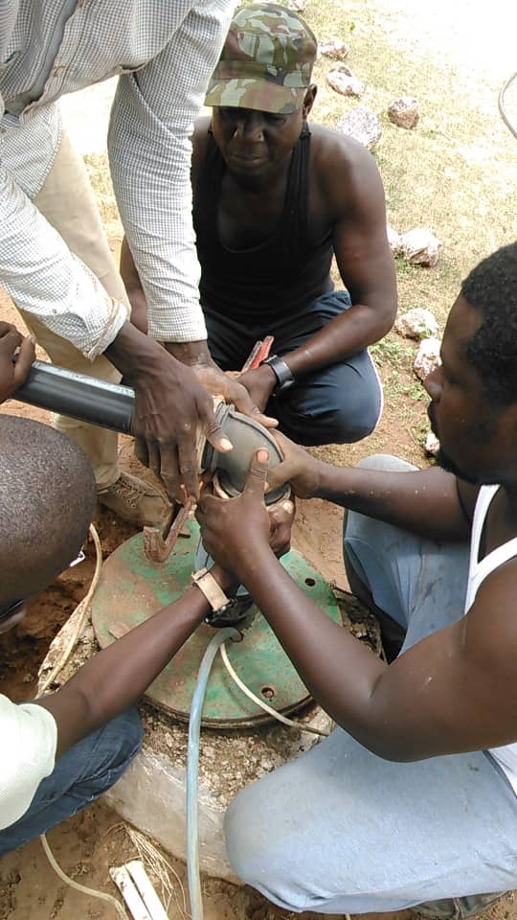

In September 2019 - thanks to numerous supports - with 100 children, we organized a day trip from Bondali to the coast 130 km away. We were traveling all day with an old big bus. We saw the small museum in the state capital, climbed on the triumphal arch that was built to commemorate the country's independence, feared a crocodile pool and fortified ourselves with chicken and chips in a small beach hotel. But the nicest moment was when we went to the beach at the end of the day: The kids saw the ocean for the first time in their life! The glow and sparkles in the eyes of children had been unforgettable! Suddenly the world was so big and wide... Education can change lives!
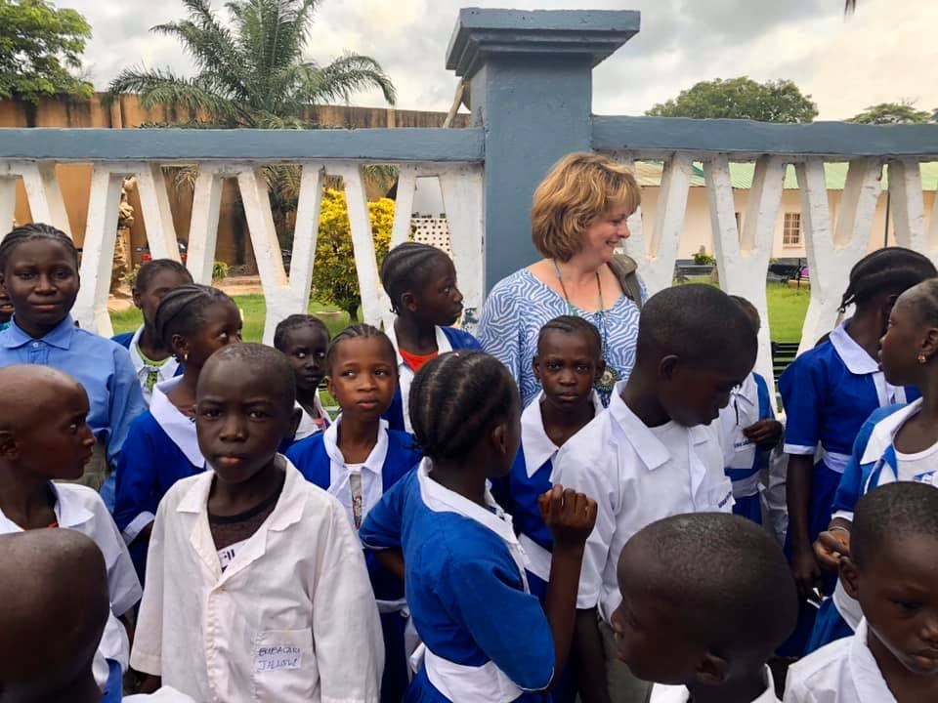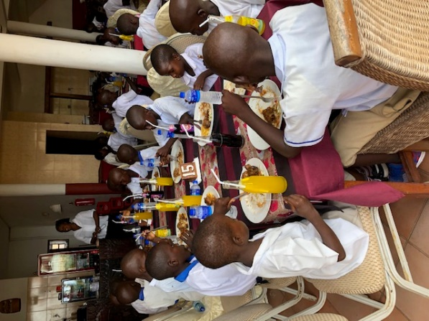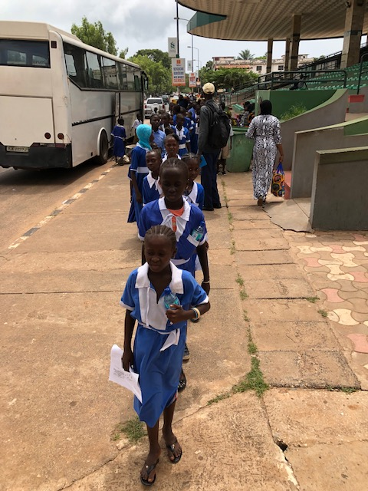
In September 2020 the first children will graduate from primary school and we are working on scholarships for secondary school. We want to try to finance five of the best graduates of the school with € 300 each for 6 years.
Every child should learn to read! - Bondali and his schoolchildren appreciate any help!

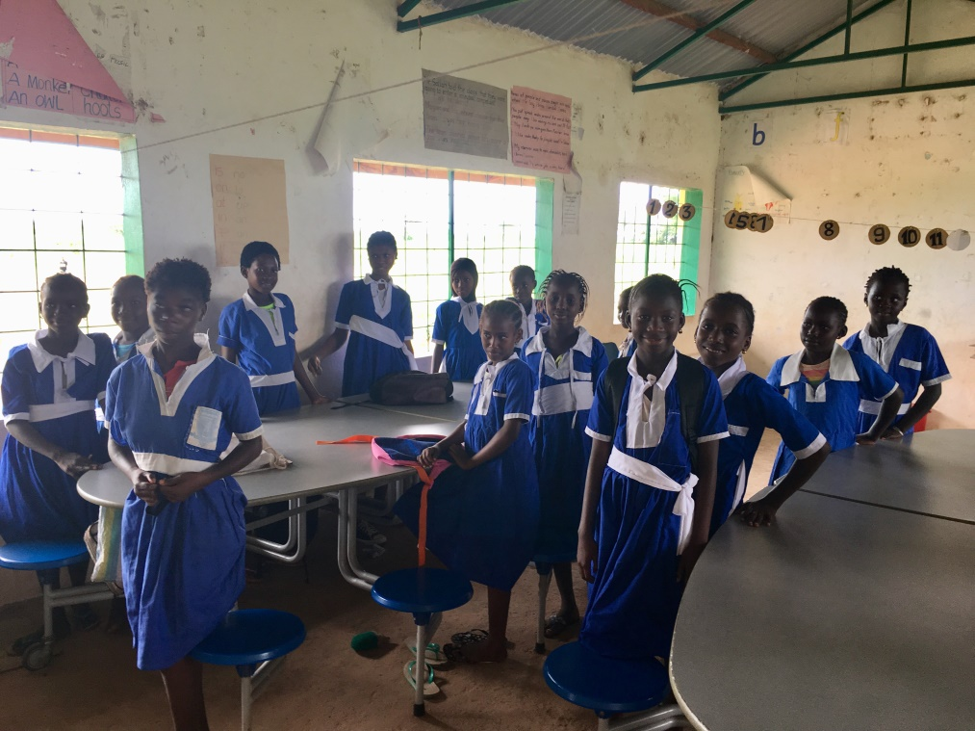

Five godparents have already been found for six years. Taibou Jobe, the headmaster of the school will have a difficult task choosing the best students.

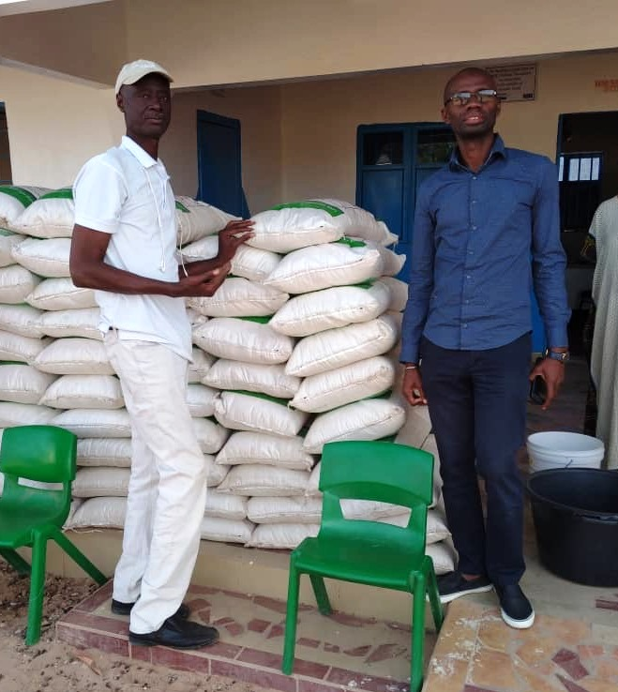 Taibou Jobe and Mafugi Drammeh
Dear friends of the Catarina Mellon School in Bondali,

shutdown in Gambia - everything is closed! Yes, Corona has also arrived in The Gambia and although there are only a few Corona cases at the moment, the biggest problem is water and rice! Nobody earns anything and there are no social benefits or even health insurance!
At the end of April we were able to send 70 sacks of rice to Bondali and thus secure the basic food for four weeks! At the end of May we send the second time 70 bags of rice to Bondali.
I don't want to attack our money for school sponsorships at the moment. All the more individual donation is welcome these days!

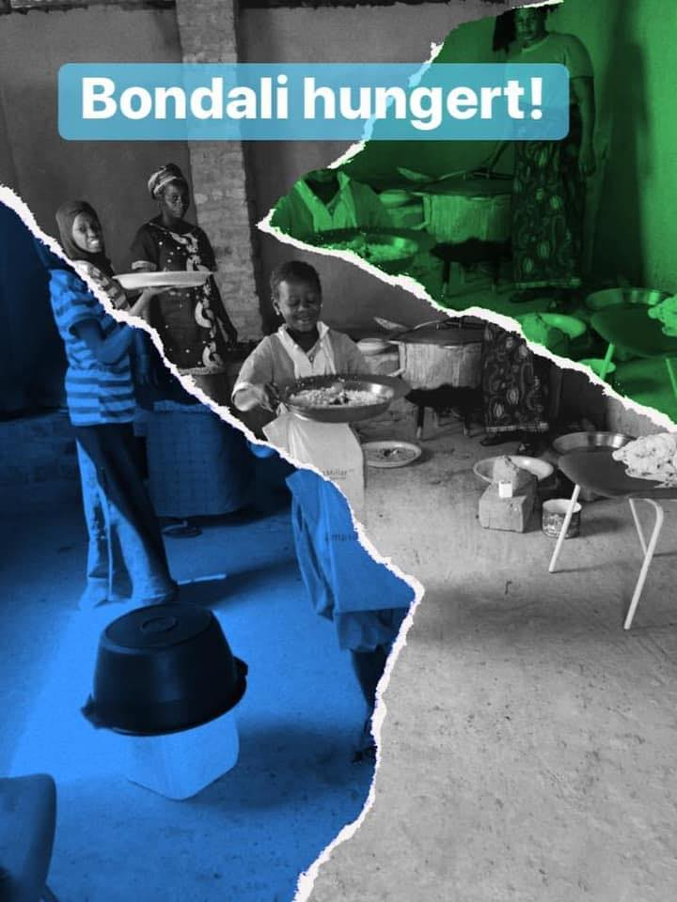

The shutdown is enlarged for 21 days more! By end of June the kids of Bondali need you help again!
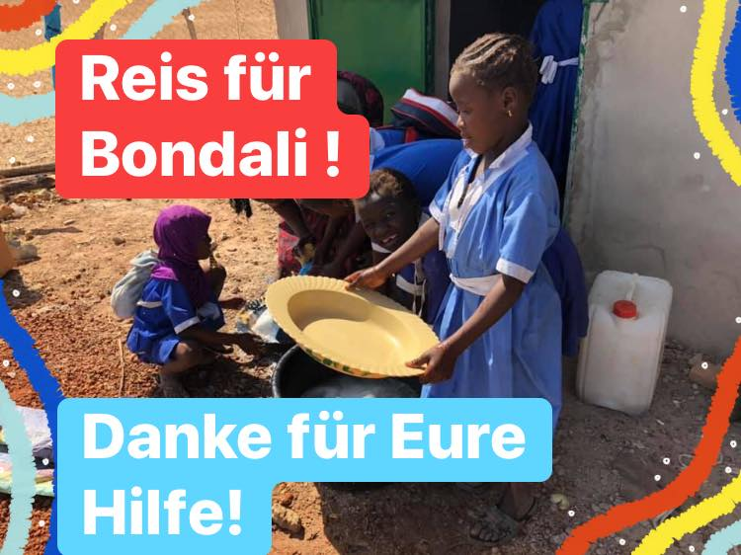

It is still a purely private campaign - supported by friends, acquaintances and family, for which I also travel to The Gambia myself every time. The project is organized in the Gamiba by Mafugi Drammeh.
We cannot issue donation receipts.
The project is officially recognized by the Gambian government as the “Catharina Mellon Foundation”.

bondalischool@gmail.com
Spendenkonto
Daniela Filthaut
Barclay Card
Kontonummer 2013372333
BLZ 20130600
DE 212 0130 600 201 337 2333

In the press
